## AIM: Draw Class Diagram and specify all relationship in the reference of specific topics provided to you.

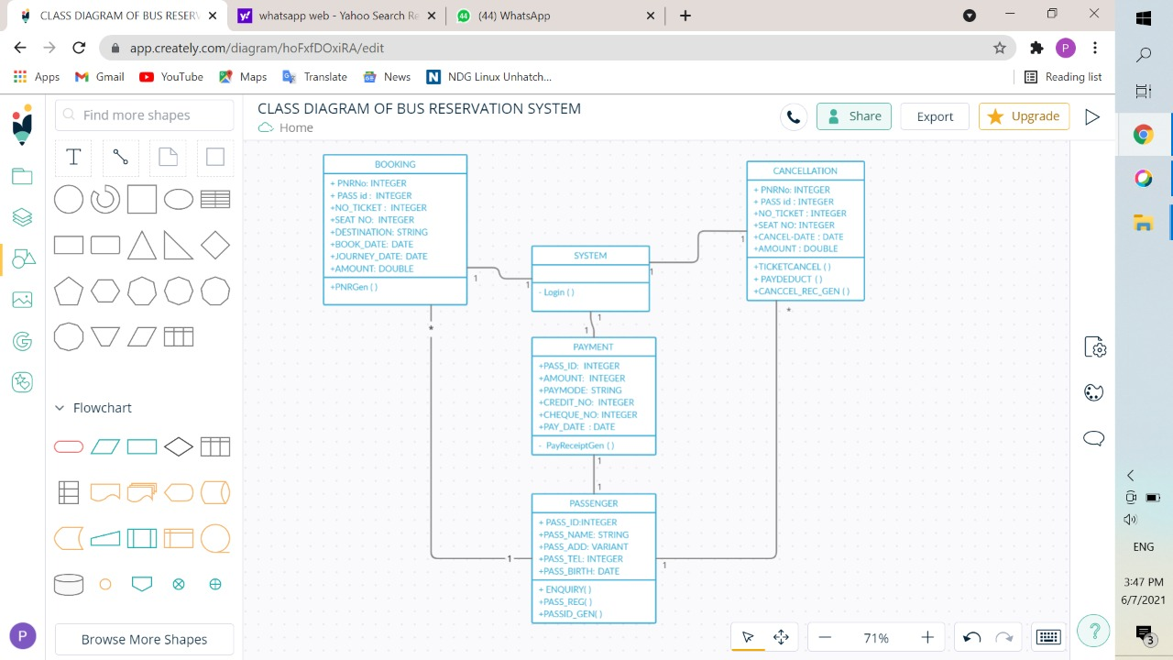

Specifications of all the relationships in the reference are as follows:

1. **Booking** – System (One to one): - One passenger can be allotted only one seat in the system and be given unique passenger id. There can’t be multiple bookings in the name of same passenger.
2. **Cancellation** – System (One to one): - Passenger can cancel his/her booked seat by providing his/her unique passenger id or seat number. And the amount will be refunded to that individual person only.
3. **Booking** – Passenger (Many to One): - One passenger can make as many number of seat bookings in the bus, but not with the same name.
4. **Cancellation** – Passenger (Many to One): - One passenger can cancel as many number of his/her booked seats in the bus.
5. **System** – Payment (One to one): - A passenger can pay for his/her booked seats only. One payment receipt will be generated against the payment done.
6. **Payment** – Passenger (One to one): - Passenger can do the payment once for his/her tickets.